1. What is a Network?
Definition
A network is a group of connected devices that communicate and share resources.
Real World Examples
- Public transportation systems
- National power grids
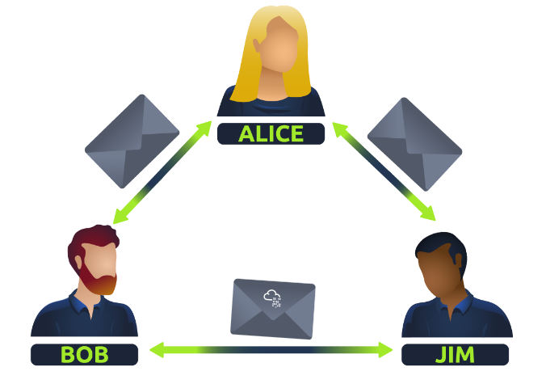
- Postal systems
- Social connections
Computing Examples
- Computers
- Phones
- Servers
- Cameras
- IoT devices
- Traffic systems
Key Point
Networks can range from:
- 2 devices
to
- Billions of devices

2. The Internet
Definition
The Internet is a global network made up of many smaller networks.
Network Types
Type | Description
Private Network | Internal/local network
Public Network | Internet/global network

3. History of the Internet
Year | Event
1960s | ARPANET created
1989 | World Wide Web invented
WWW invented by:
Tim Berners-Lee

4. Device Identification
Devices use two identifiers:
Identifier | Purpose
IP Address | Logical identification
MAC Address | Physical identification

5. IP Address
Definition
An IP address identifies a device on a network.
IPv4 Structure
192.168.1.1
- 4 octets
- Range per octet: 0–255

6. Public vs Private IP
Type | Usage
Private IP | Local network communication
Public IP | Internet communication
Example
Device | Private IP | Public IP
PC1 | 192.168.1.77 | 86.157.52.21
PC2 | 192.168.1.74 | 86.157.52.21

7. IPv4 vs IPv6
IPv4
Uses:
2^{32}
≈ 4.29 Billion addresses
Example:
192.168.1.1

IPv6
Uses:
2^{128}
Very large address space
Example:
2001:0db8:85a3:0000:0000:8a2e:0370:7334
Benefits
- More IP addresses
- Better efficiency
- Solves IPv4 shortage

8. MAC Address
Definition
A unique hardware address assigned to a network interface.
Example
a4:c3:f0:85:ac:2d
Structure
Part | Meaning
First 6 characters | Manufacturer
Last 6 characters | Unique device ID

9. MAC Spoofing
Definition
Changing/faking a MAC address to impersonate another device.
Risk
Can bypass weak security controls.

10. Ping
Definition
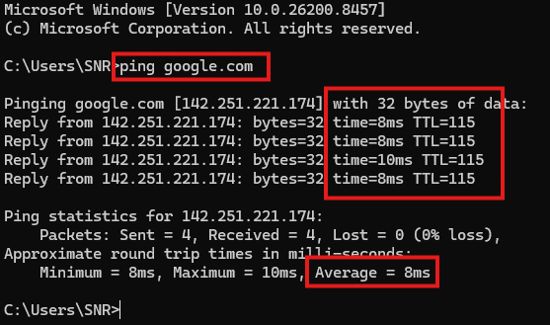
A network utility used to test connectivity.
Uses:
- ICMP protocol
Syntax
ping 8.8.8.8

11. ICMP
Full Form
Internet Control Message Protocol
Purpose
- Connectivity testing
- Network diagnostics

12. LAN Topologies
Definition
Topology = layout/design of a network.

13. Star Topology
Structure
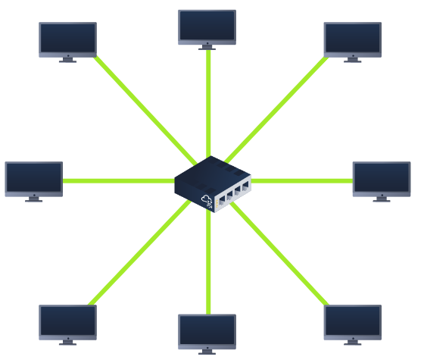
All devices connect to a central switch/hub.
PC1
|
PC2 --SWITCH-- PC3
|
PC4
Advantages
- Reliable
- Scalable
- Easy device addition
Disadvantages
- Expensive
- Central device failure affects all

14. Bus Topology
Structure
All devices share one backbone cable.
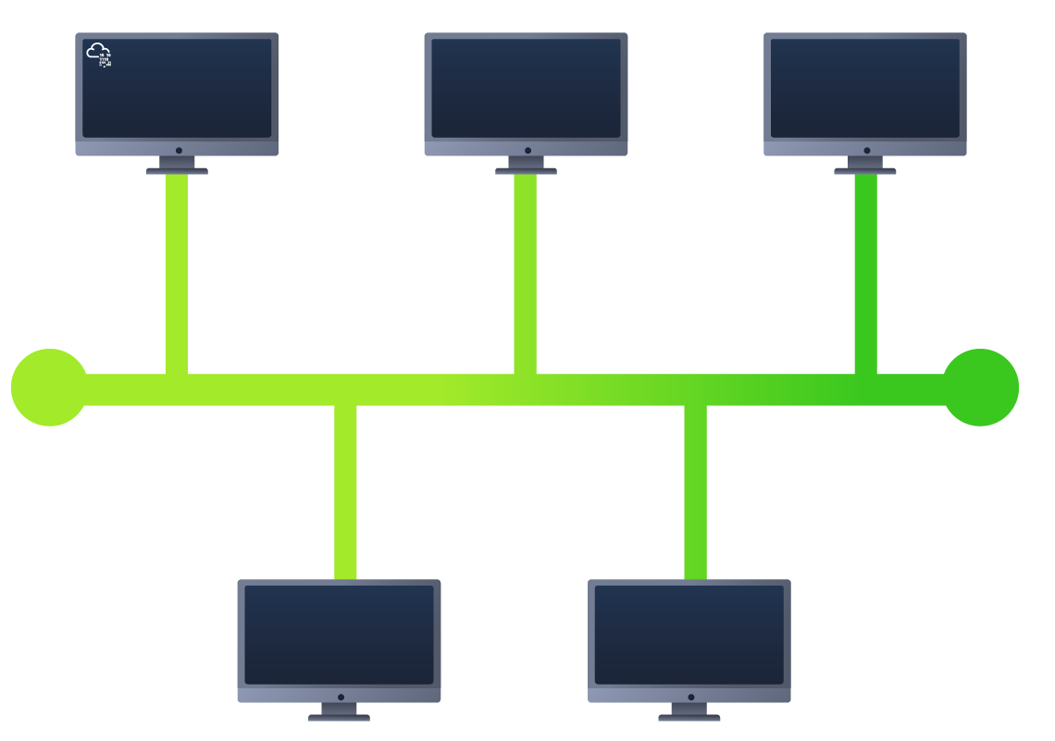
PC1 -- PC2 -- PC3 -- PC4
Advantages
- Cheap
- Easy setup
Disadvantages
- Bottlenecks
- Single point of failure
- Difficult troubleshooting

15. Ring Topology
Structure
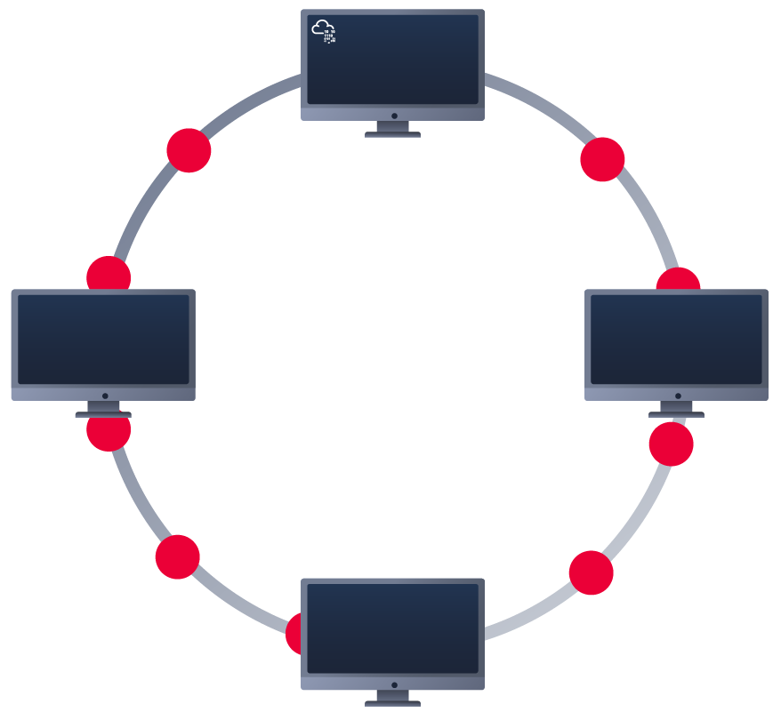
Devices connected in a loop.
PC1 -- PC2
| |
PC4 -- PC3
Advantages
- Less cabling
- Fewer bottlenecks
Disadvantages
- One failure breaks network
- Slower routing path

16. Switch
Definition
A device that connects multiple devices in a LAN.
Functions
- Sends traffic to correct device
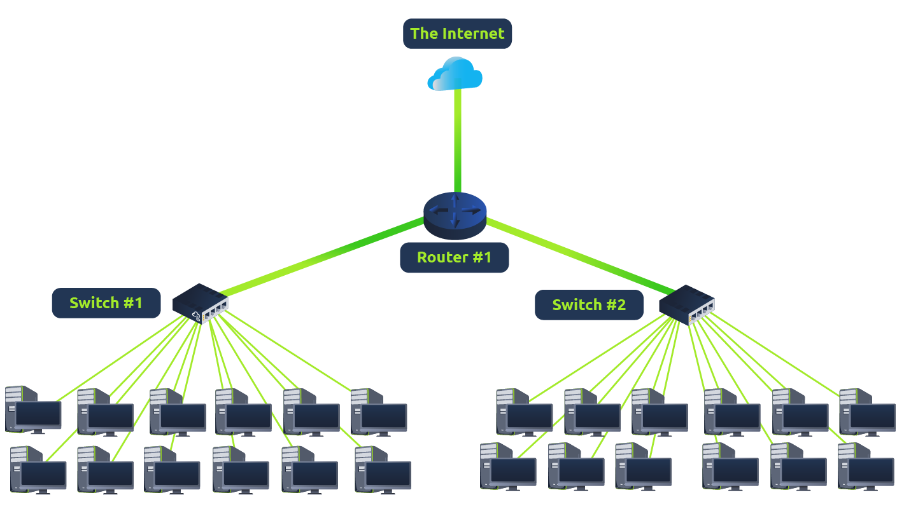
- Reduces unnecessary traffic
Port Sizes
- 4
- 8
- 16
- 24
- 48
- 64

17. Router
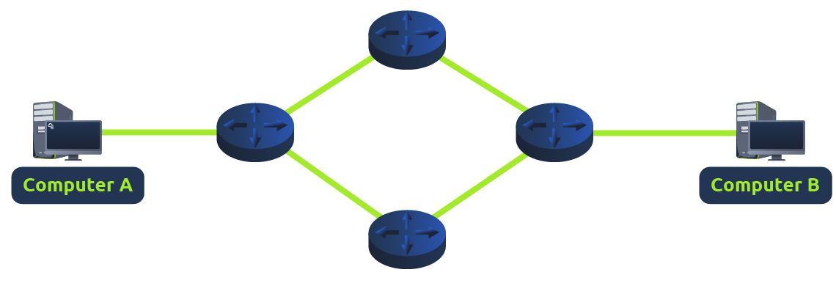
Definition
A device that connects different networks.
Main Function
Routing packets between networks.

18. Routing
Definition
Process of determining the best path for data.
Factors
- Shortest path
- Reliability
- Fastest medium

19. Subnetting
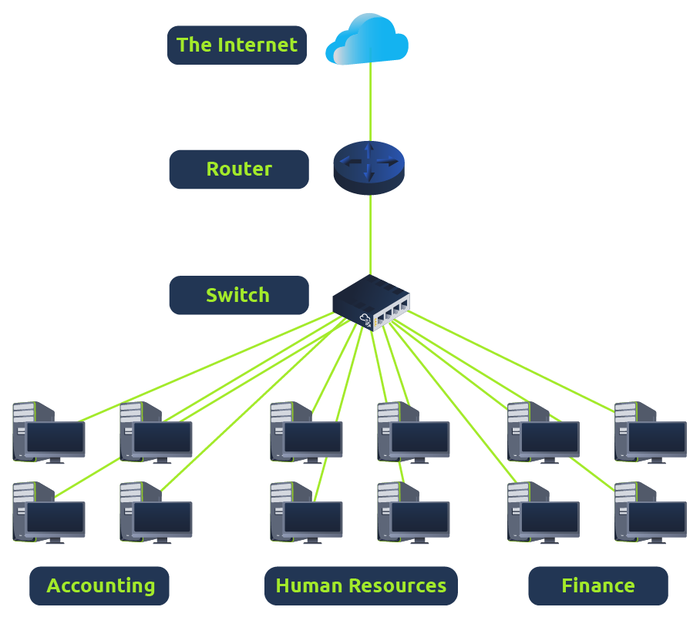
Definition
Dividing a network into smaller subnetworks.
Benefits
- Efficiency
- Security
- Better management

20. Subnet Mask
Example
255.255.255.0
Used to identify:
- Network portion
- Host portion

21. Types of Addresses in Subnetting
Type | Example | Purpose
Network Address | 192.168.1.0 | Identifies network
Host Address | 192.168.1.100 | Identifies device
Default Gateway | 192.168.1.254 | Connects outside network

22. ARP
Full Form
Address Resolution Protocol
Purpose
Maps:
- IP Address ↔ MAC Address
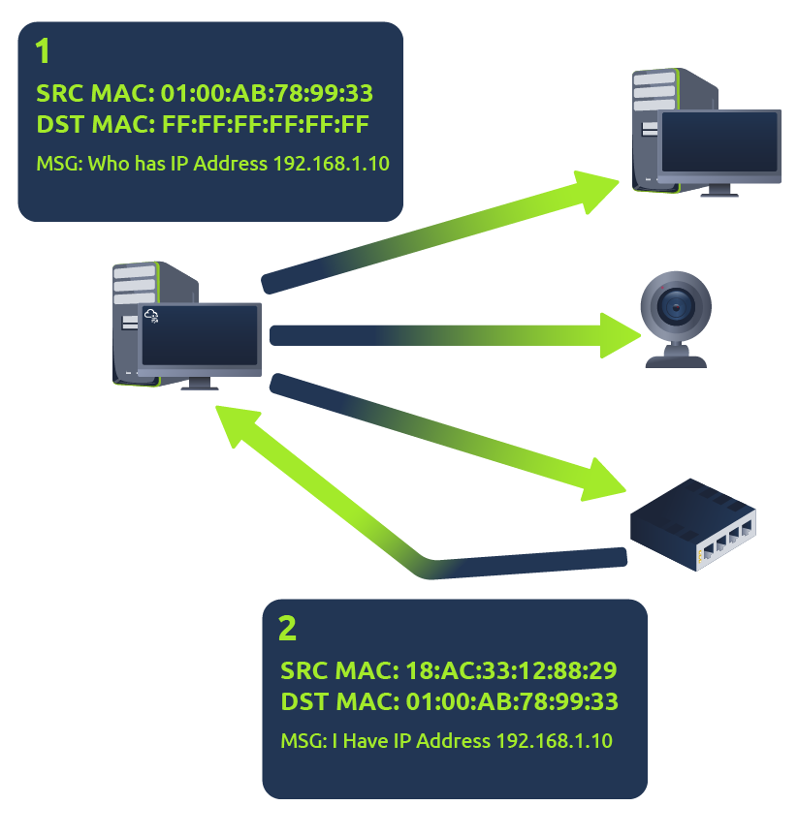
23. ARP Process
ARP Request
Who owns this IP?
ARP Reply
This MAC belongs to that IP

24. ARP Cache
Definition
Stores IP-to-MAC mappings temporarily.

25. DHCP
Full Form
Dynamic Host Configuration Protocol
Purpose
Automatically assigns IP addresses.
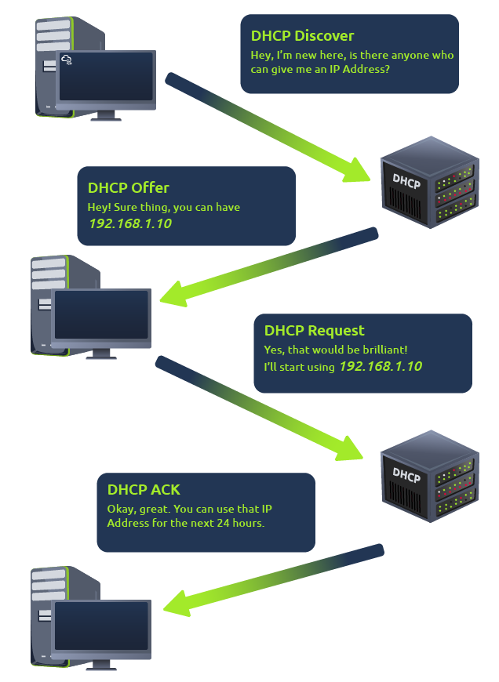

26. DHCP Process (DORA)
Step | Meaning
Discover | Search DHCP server
Offer | Offer IP
Request | Request offered IP
ACK | Confirm assignment

27. OSI Model
Definition
A 7-layer networking framework.
Layer | Name
7 | Application
6 | Presentation
5 | Session
4 | Transport
3 | Network
2 | Data Link
1 | Physical
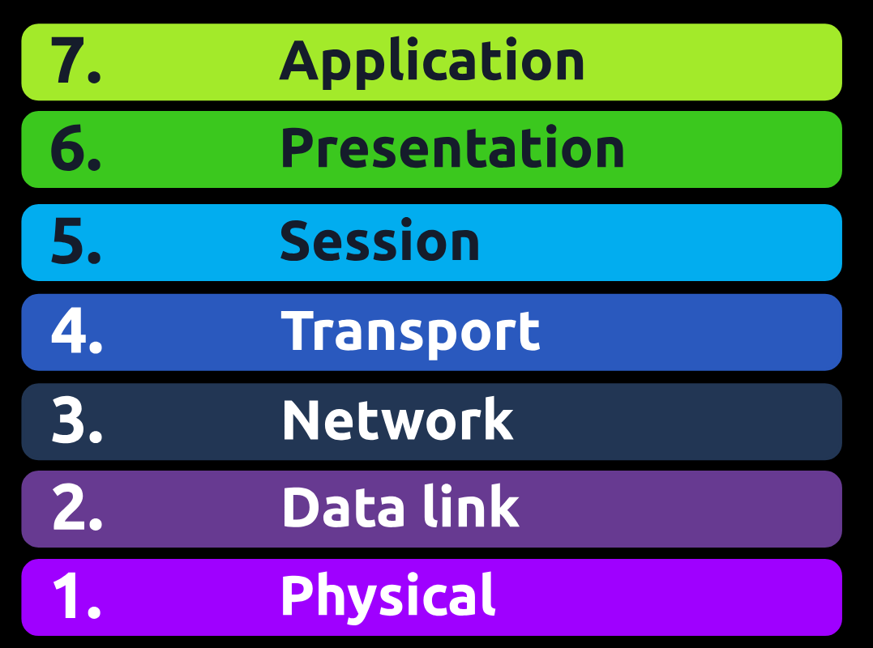
28. Physical Layer (Layer 1)
Responsibilities
- Physical transmission
- Electrical signals
- Binary communication
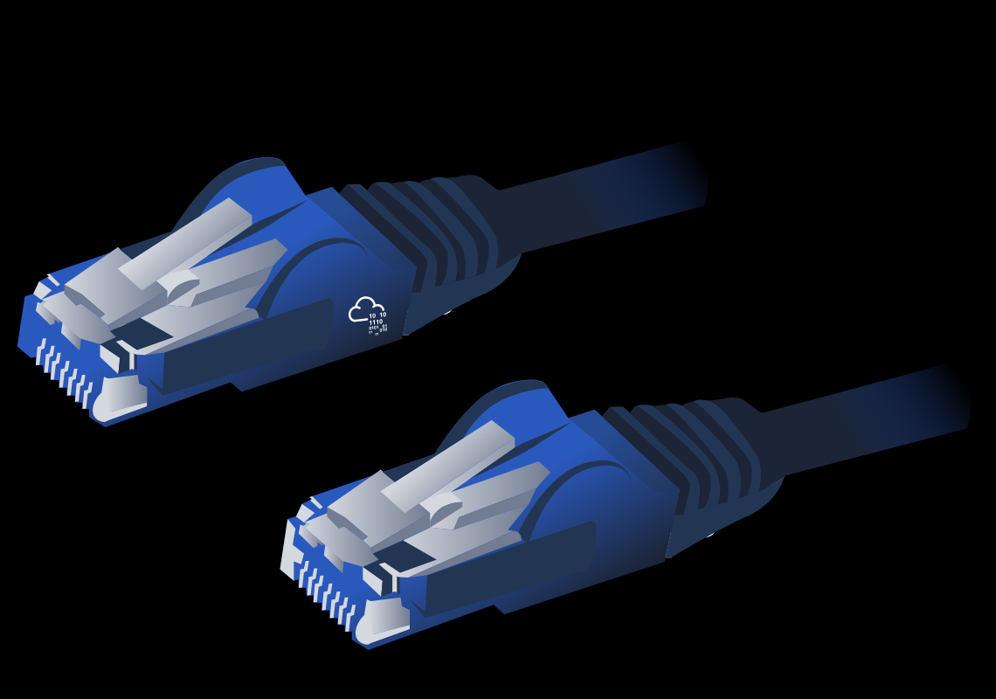
Example
- Ethernet cable

29. Data Link Layer (Layer 2)
Responsibilities
- MAC addressing
- Frame transmission
Device
- Switch

30. Network Layer (Layer 3)
Responsibilities
- Routing
- IP addressing
Device
- Router

31. Transport Layer (Layer 4)
Responsibilities
- Data transport
- Reliability
- Error checking
Protocols
- TCP
- UDP

32. Session Layer (Layer 5)
Responsibilities
- Establish sessions
- Maintain connections
- Close sessions

33. Presentation Layer (Layer 6)
Responsibilities
- Translation
- Encryption
- Formatting
Example
- HTTPS encryption

34. Application Layer (Layer 7)
Responsibilities
User interaction with network services.
Examples
- Browsers
- Email clients
- DNS

35. Packets vs Frames
Packet | Frame
Layer 3 | Layer 2
Contains IP info | Contains MAC info

36. Packet Headers
Header | Purpose
TTL | Packet expiry
Checksum | Integrity check
Source Address | Sender IP
Destination Address | Receiver IP

37. TCP
Full Form
Transmission Control Protocol
Features
- Reliable
- Connection-oriented
- Error checking
Uses
- File transfer
- Email
- Web browsing

38. TCP Three-Way Handshake
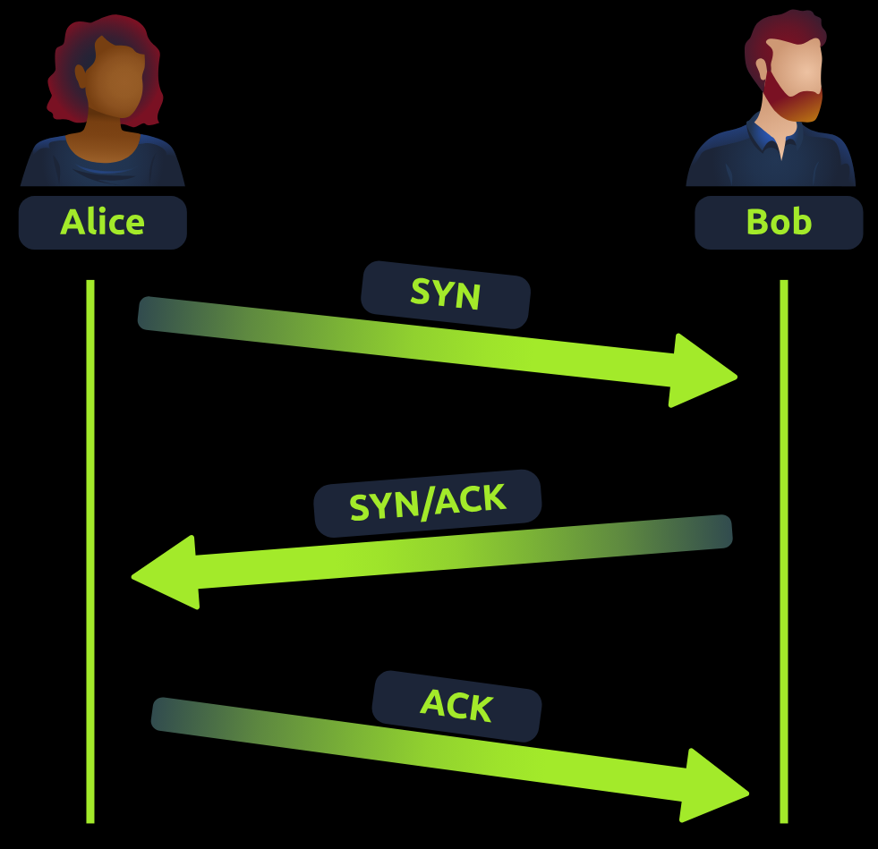
Step | Message
1 | SYN
2 | SYN/ACK
3 | ACK

39. TCP Closing Connection
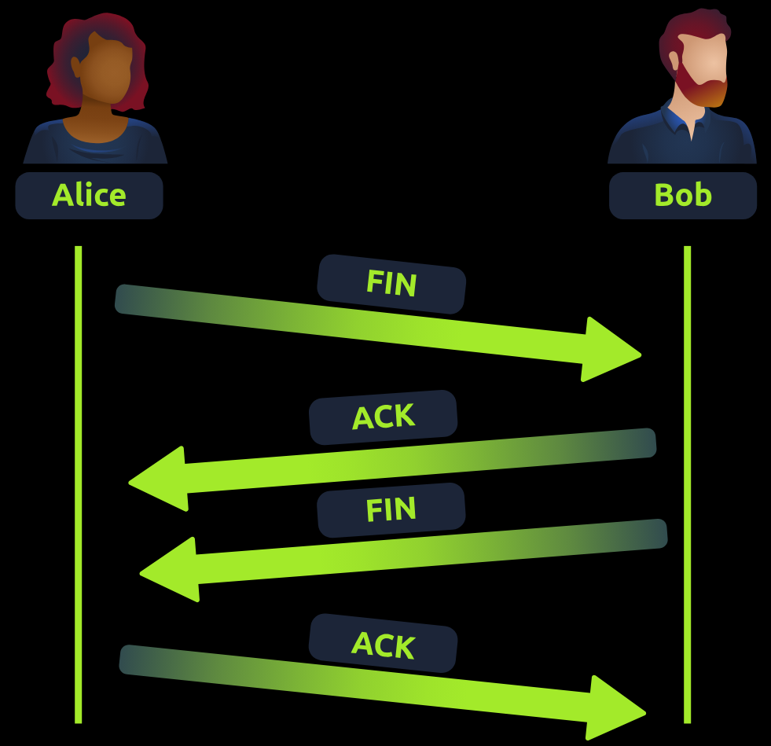
Step | Purpose
FIN | Request close
ACK | Confirm close

40. UDP
Full Form
User Datagram Protocol
Features
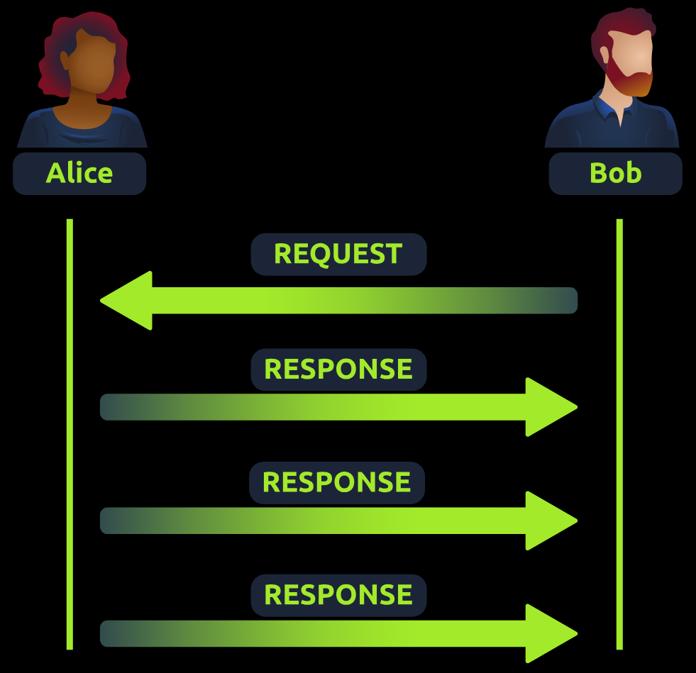
- Fast
- Connectionless
- No guarantee of delivery
Uses
- Streaming
- Voice chat
- Gaming

41. TCP vs UDP
TCP | UDP
Reliable | Faster
Connection-oriented | Connectionless
Error checking | No guarantee
Slower | Faster

42. Port Forwarding
Definition
Allows external devices to access internal services.
Example
Public users accessing internal webserver.
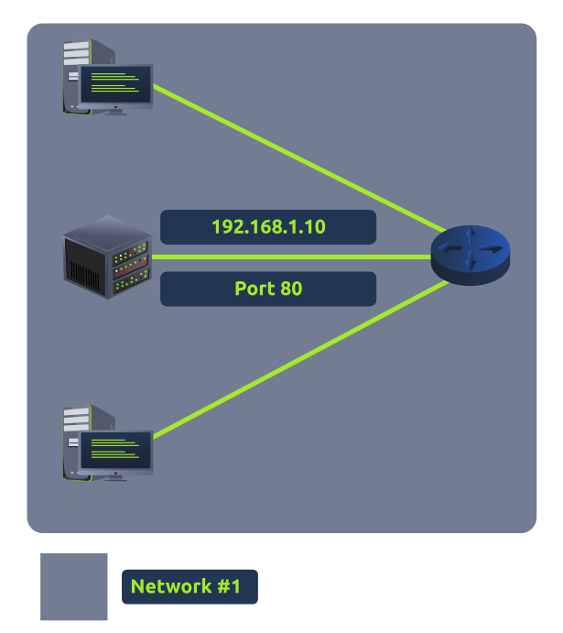
If the administrator wanted the website to be accessible to the public (using the Internet), they would have to implement port forwarding, like in the diagram below:
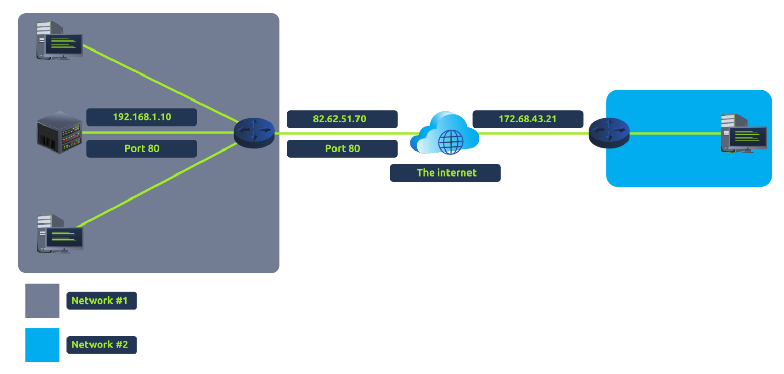

43. Firewall
Definition
Controls allowed and blocked network traffic.
Checks
- Source
- Destination
- Port
- Protocol

44. Firewall Types
Stateful Firewall
- Tracks entire connection
- More intelligent
- Resource intensive
Stateless Firewall
- Uses static rules
- Faster
- Less intelligent

45. VPN
Full Form
Virtual Private Network
Purpose
Creates encrypted tunnel over Internet.

46. VPN Benefits
Benefit | Description
Privacy | Encrypts traffic
Security | Safe communication
Remote Access | Connect remote offices
Anonymity | Hides activity

47. VPN Technologies
Technology | Description
PPP | Authentication/encryption
PPTP | Easy setup
IPSec | Strong encryption

48. Layer 2 vs Layer 3 Switch
Layer 2 Switch | Layer 3 Switch
Uses MAC addresses | Uses IP + MAC
Frame forwarding | Routing + switching

49. VLAN
Full Form
Virtual Local Area Network
Purpose
Virtually separates devices on same switch.
Benefit
Improves:
- Security
- Traffic management
- Segmentation

